Press release 2011

Le Grenier à Pain/ Michel Galloyer

Another type of bakery

www.legrenierapain.com

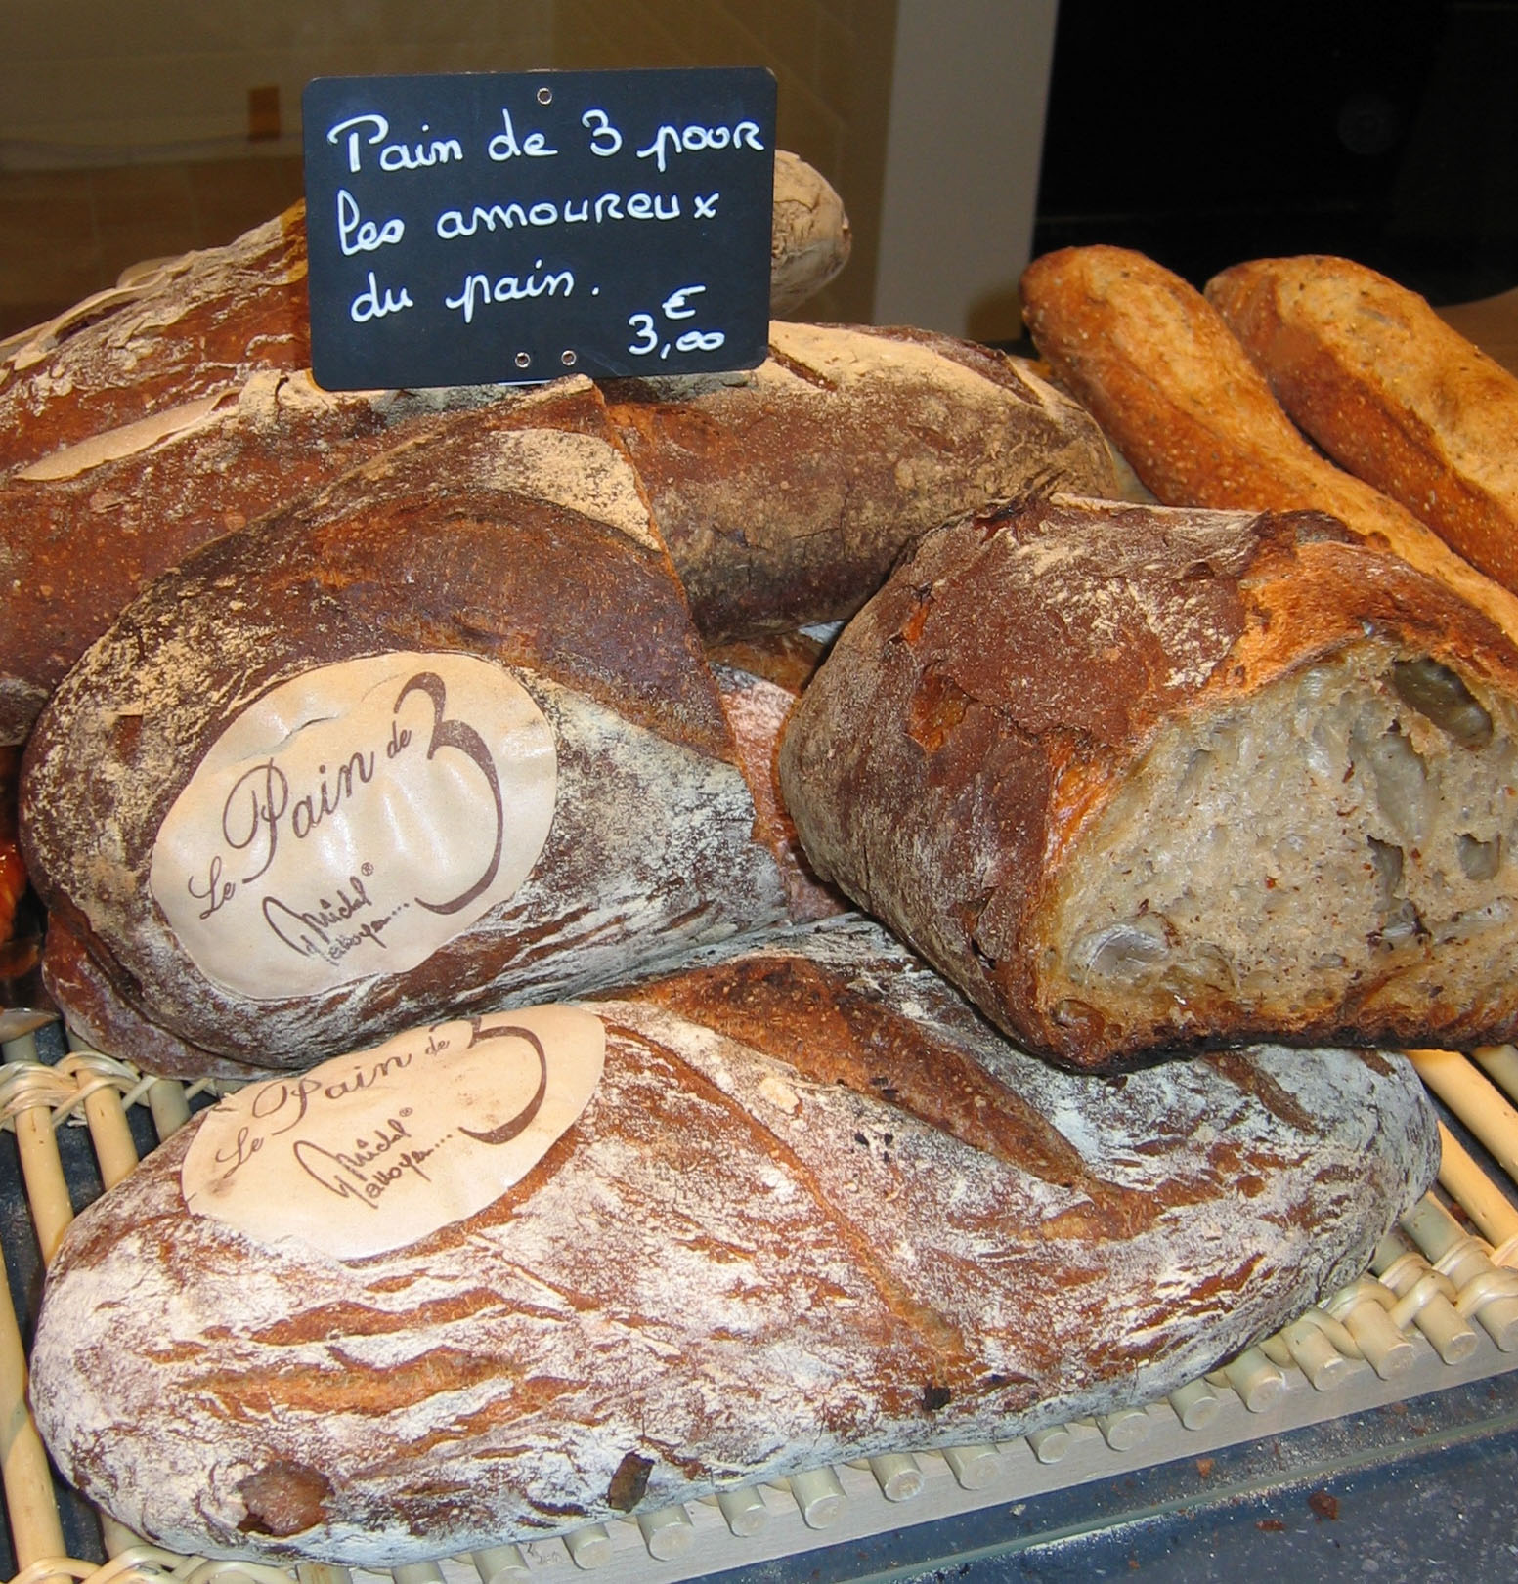

The unusual career path of Michel Galloyer
A man who knows how to roll his sleeves up …

Straight out of the mould :

Born on 28 December 1945, in Saulges in Mayenne.
This city with character is the birthplace of a man set to be noticed: Michel Galloyer. His parents are farmers, and, very early on, he learns the basics of life on the farm where the seasons set the pace of everyday life. A rigorous upbringing gives him a taste for work and simple values that will never leave him, whereas his vocation is imposed on him: he will be a baker-cake maker. A first internship at the age of 14 years old, followed by employment as a prep cook till 1964, the year of military service, then marriage and the birth of Géraldine bring Michel to set up his own business: at 22 years old, he is the happy owner of a bakery in Bellême, in Orne. But the city soon becomes too small for his ambitions: he dreams of new cakes and innovative recipes: after having done internships at the Lenôtre School, Michel opens a new place in Angers, Le Trianon, which, with its charming Louis XVI décor and its shop window full of mouth-watering goodies, quickly becomes a must in the city, skilfully run by the Galloyer couple. The following step is the consecration of his know-how with admittance to the prestigious Relais Dessert International association which ordains the one hundred best gastronomic artisans in the world: in 1988 Michel is not only a member, but is also awarded the trophy.

Learn and train

Then comes the fantastic experience of being a trainer, outside Paris and all over the world, which leads him to a new challenge: open, first in Angers, then in Paris, traditional bakeries, where the memory of old-fashioned recipes will be brought up to date. He has an ally for this: Philippe Viron, owner of the famous flour-mills that have existed since 1815. The latter wants to bring back the traditional baguette, the one that was made in the 1930s, whose unbleached dough was prepared with pure flour in slow turning kneading machines. As Michel points out, "baguettes represent 85% of sales in a bakery. So they have to be the best in the neighbourhood.” The idea of all-kinds of rustic breads then took off. Leading to the bread of 3, that can be kept for 3 or 4 days, the magnificent ardéchois, the star of Sunday meals, bread rolls with different flours, speckled with walnuts or raisins, different types of fougasse with olives, cheese or bacon… a dozen varieties, with the baguette remaining the star: between 1200 and 2000 are baked every day in each bakery!

Take the best of the old and the new.

The creation of the Greniers à Pain :

With Anne-Marie Guillard, the initiator of the Parisian adventure, the first Grenier à Pain was opened at 52 avenue d’Italie in 1998 and its immediate success brought about the opening of, up to now, about thirty shops. The recipe is eloquent: no putting on airs, real, authentic products on the counter and in the decor. As for the traditional ovens, they are, as in the bakeries of yesteryear, visible to the public, even if behind them, there hides a range of modern, high-performance equipment. The birth of Greniers à Pain under licence was not far behind. From the training workshop of Michel Galloyer, set up in Angers, come bakers who, and who only, have the privilege of opening shops under this brand. This way, the work base is identical in each place, with varieties adapted to the diverse customs of French regions. This quickly leads to an international take off, in Japan, where Michel Galloyer is very appreciated, the Middle East and in China, not forgetting Great Britain, the French know-how delights those who love real French bread. But what will the next challenge of Greniers à Pain be? The future is for those you believe in their dreams, says Michel Galloyer, who knows not only how to dream but also how to make his dreams a reality!

Some figures and dates

Main dates

1960-1963: Apprenticeship in baking, cake-making.
1963-1968: Cake-making employee in Paris.
1968-1976: bakery-cake shop in Bellême.
1976: Creation of the luxury “Le Trianon” cake and chocolate shop in Angers.
1986: Plat Vermeil for cake and chocolate making.
1987: Opening of a bakery, cake shop in the Halles in Angers.
1988 – 1989 – 1994 : Paris International Chocolate Award.
1992: Consulting for and creation of Cannelle cake shop, bakery in Beirut (Lebanon).
1994: Rabelais d’Or for cake making.
1995: Gold Medal for cake making in Tokyo (Japan).
1996: Grand Départemental Companies Trophy for Maine and Loire.
1997: National Award for Dynamic Craft Work.
1998: Opening of the first Grenier à Pain in Paris XIIIth.
1999: Mercure d’Or category “employment, training, development of human resources”.
2002: Opening of the Grenier à Pain brand licence.
2003: 3 ears of corn in the book “Cherchez le pain” by Steven Kaplan (éditions Plon).
2005: Presentation at the chocolate tradeshow in Paris with the collaboration of the leather goods manufacturer Lancel.
2005: 1st prize in the competition for the best butter croissant, Paris
2005: 3rd Master Prize for the best baguette, Paris.
2006: Officer of the Legion of Honour.
2006: Exhibition at the chocolate tradeshow in Paris of a chocolate robeen made with the creator Biche de Bere.
January 2008: report in the scope of the programme Capital for M6 and participation as invited guest of the official delegation of the state visit of Nicolas Sarkozy to India.
March 2008: publication of the first issue of the Lettre du Grenier.
2008: Publication of the book “Pourquoi Pas Moi”, press meeting with Minister Lagarde.
March 2010: 1st Prize for the Best Baguette in Paris, Le Grenier à Pain Les Abbesses, Djibril Bodian.
May 2010: The Elysée invites Djibril Bodian and Michel Galloyer.
June 2010: Opening of the Grenier à Pain in Vichy.
July 2010: Opening of the Grenier à Pain in Poissy.
October 2010: Opening of the Grenier à Pain in Rennes.

TURNOVER 2010:
15 million Euros.
STAFF:
260, of which 40 are apprentices.

A BAKING-CAKE MAKING SCHOOL

The Michel Galloyer training workshop is based in Angers. It receives trainees from all over the world, and many apprentices are regularly welcomed to the different shops in the group. The Grenier à Pain managers all come from this school.

A DEVELOPING COMPANY

with an important international network based on traditional know-how and certain demands in the choice and the origin of the products used to make the bread and cakes. Today the Grenier à Pain/Michel Galloyer label is one of the most dynamic and recognised ones in the sector.

BOOKS

“Chocolat et gourmandises” Ed. de l’If, 2005.
“Douceurs et gourmandises pure canne” with Vincent Joly. Ed. de l’If, 2006.
“Pourquoi pas moi” autobiography with a preface by Roselyne Bachelot and Pierre Hermé. Ed Thoba’s, 2007.

All are available at the Greniers à Pain.

Production :

BREAD

10 types of bread; brown, leavened, apricot, hazelnut, fig and walnut, olive fougasses ... are added daily to the flagship product: “The traditional Baguette”, prize for excellence 2010 awarded by Djibril to the Grenier à Pain des Abbesses 75018.

CAKES

There are 30 types of cakes that change with the seasons with 4 new annual collections including the traditional éclairs, tartes Tatin and Paris-Brest passing by clafoutis, together with all sorts of cake creations that are real pieces of art. And a whole range of packets of biscuits: Jules shortbread, palets bretons and galettes bretonnes

SWEET BREADS and OTHER TREATS

Fruit cakes with vanilla and chocolate, madeleines or chocolate tarts can be added to the traditional pure butter croissants and pains au chocolat.

CAKES THAT CAN BE EASILY TRANSPORTED

These are the originality of the shop and originate from old fruit cake and madeleine recipes flavoured with vanilla and chocolate, they are easy to transport and can be kept for a long time.

THE DECOR

Inspired by the décor of shops of yesteryear: floors with varnished hexagonal floor tiles, country-style cupboards, hanging lights.

THE PACKAGING

The original aspect of it is that it is designed as a little cardboard basket with a handle to transport cakes elegantly and safely. The fruit cakes are displayed in the greaseproof paper they were cooked in and keep their white frill.

30 shops with the Grenier à Pain sign

FRANCE

Paris:

91, fbg Poissonnière, 75010
12, rue du 8 mai 1945, 75010
149, fbg St Antoine, 75011
52, av d’Italie, 75013
134, rue St Charles, 75015
33 bis, rue St Amand, 75015
38, rue des Abbesses, 75018
127, rue Caulaincourt, 75018
174, rue Ordener, 75018

Paris Region:

1 bis, bd Jean Jaurès, Boulogne
53, rue du Pt Wilson, Levallois
107, Grand Rue, Sèvres
101, rue Général Leclerc, Poissy

Outside Paris:

Angers (49), Avrillé (49), Saint-Barthélémy
d’Anjou (49), Trélazé (49), Nantes (44),
La Baule (44), Lorient (56), Ploërmel (56),
Rennes (35), Le Rheu (35), Moulins (03),
Vichy (03), Royan (17)

Michel Galloyer ABROAD

Lebanon, Middle East, Japan, China, Russia, Singapore.

A day with the business owner Michel Galloyer :

Michel Galloyer: “The world belongs to those who get up early!”

My day is an early start, a good coffee, some "fromage blanc" and fruit, with a read of my local paper: the Courrier de l’Ouest in Angers or the Figaro in Paris. Then I have a look at my iPhone, give a thought to Angers, my town, my work, my friends, my reference points… When I am in Angers I head for the office, where I am present or on the phone with my secretaries and my accountant from 9am. At the “Grenier à Pain” in Angers, I am close to the team, we discuss key points, we taste, we speak about recipes. Then I take the train for Paris. I have time to work during the trip, or have a coffee with friends at the TGV bar. Then I visit the Parisian Greniers à Pain by taxi or in my little Smart. I like having a chat with the teams there, I know them all, it’s important. Then, a meeting with Vincent, the group manager: we speak about essential things; recruitment, and the sensitive points of different applicants. Then it’s meeting after meeting. I like meeting new people, having a bit of time to myself and learning about new things in the profession. That’s how my day goes, peppered with some fun with loved ones. Sometimes it ends with a cosy dinner with friends or with professionals, or at home for a quiet night. Sometimes I have to travel to Lebanon, to Asia, for example, where we're shortly going to open in China. We have projects in Russia, Vietnam and in Morocco… Abroad I am spoilt and pampered, I have done training throughout the world since 1990. I have met men, and especially women, who have made me progress and outdo myself. So time doesn’t count for me, all my weekends are very busy, reviewing, amongst others, the accounting with Jean-Bernard at the office on Saturday mornings. I also travel a lot, covering 80,000 km a year in my car, from Angers to Brittany, Paris and the cities where we have Greniers à Pain.

“Knowing how to manage one's time is the most difficult thing!”

The most difficult thing for me is to manage things, keep my family and those dear to me happy without clashes or conflicts. To do this it is necessary to like people, and have a minimum dose of hypocrisy to honour the many private, professional and indeed restricting activities. I travel every day, I don’t have a holiday, just some breaks, and I manage to do everything without a diary, I don’t write anything down, I have an excellent memory and I don’t forget much! I don’t age, but I do get older without ever feeling tired. Here you have a snapshot of a week that can last eight or nine days… And if I decide to get away for 48 hours without saying anything to anyone, maybe that’s true happiness!

What he likes… What he doesn’t like…

I’m passionate about classic cars, lovely English ones in particular, and also about modern ones that take me to Brittany, to Ploërmel. I like having a little Savennières white with my friends on Sunday whilst we put the world to rights. I like the natural beauty of women. I love women with light eyes that appreciate humour. I like excellence with simplicity. I like noble products. Good, not too old wines. I like passionate and fascinating people of all ages, well-read and cultivated people. I like Japan for its rigour and its discovering frenzy. I don’t like careless, mean, people, freeloaders. I don’t like negative, "yes, but" people. I don’t like envious, jealous people. I hate conflicts, restrictions. I like winners who find solutions. And I hate losers, who only find excuses…

The decoration of the Greniers à Pain, a women's affair :
“In a bakery, it is necessary to develop all the senses! »

Agnès Tiry, painter and interior decorator.

Agnès thinks about, with Anne-Marie Guillard, the atmosphere of the Greniers à Pain and she organises the layout of about twenty shops, regularly coming back to adapt the locations for celebrations and seasons around a particular curiosity: the oven, visible by the customers, who can follow the baking stages. “A bakery is a place we go every day, you have to trust it”, she comments. “We have to remain vigilant so that the shops are light and warm. Traditionally, for many years, bakeries were painted shades of blue, that are, however, not “appetising” colours. Our idea has been to develop, both in Paris and outside Paris, a city-dweller feel where the country-style side is still very present: warm colours, red – like the colour of the fire in the ovens - slate, chestnut, chocolate and wood, which go well with the bread, both living materials ... The furniture that we install is adapted to the layout of each shop. The displays are made to measure and the contents of the derived products are rooted out from second-hand shops: old metal boxes, nice coffee pots, old crates for apples … And when there’s a queue the customers can read “bread words” while waiting, written here and there, “the main attraction of the shops is its bread and its poetry”.

“Decorating the shops with what we produce”
Anne-Marie Guillard, the soul of Greniers à Pain :

Owner of the shop in the rue des Abbesses in the 18th arrondissement of Paris, Anne-Marie takes her inspiration from current fashions for the decor of the bakeries. “At the time of the first Greniers à Pain, when Christmas came, I decorated them all the same, but today, considering the number of shops, I can’t anymore! We have meetings during which we speak about the theme that I've chosen, but we don't impose anything. I look at the trend books from decoration tradeshows and I pick up good ideas in trendy places in Paris! This year the Provençal Christmas theme has been selected. Olive branches will decorate Christmas tree garlands with linen knots and large almond meringues. This setting will allow us to offer our customers different products, such as highlighting the traditional 13 Provençal Christmas desserts with the oil pump or nougats ... The outside of the shops will be decorated with a big garland reminiscent of those inside.

Bread words :

Sayings

Have some bread on the board.
It’s blessed bread.
To be as good as bread.
Eat your white bread first.
I don’t eat this bread.
Sell for a mouthful of bread.
Go like hot cakes.
Take the crust from your mouth.

Quotations from authors

“Luxury is the bread of those who live for brioche. »

André Suarès

“Theatre has to make thought the bread of the crowd. »

Victor Hugo

“The best smell is that of bread, the best taste, that of salt, the best love, that of children.”

Graham Greene

“If idiots still want an acorn, let them eat it, but find a way to show them bread.”

Voltaire

“Do you think that we can be really loving, if we don't have bread?”

Father Prévost

“Man doth not live by bread alone, but faith, admiration, sympathy.”

John Keats

